ACC, HIMSS and RSNA
Integrating the Healthcare Enterprise


IHE Patient Care Coordination
Technical Framework

2005-2006

Volume 1, 2
(Vol 3 to be merged for Public Comment)

Public Comment Draft July 22, 2005

Comments due August 22, 2005

Thank you for participating in this document review!
This draft of the Patient Care Coordination Technical Framework V1.0 is submitted for Public Comment between July 22, 2005 and August 22, 2005, per the scheduled announced in May 2005.
As you read this document, there are known outstanding issues. Please keep these questions in mind in addition to any other feedback to the Technical Committee during the public comment period.
- Should the support by Document Source and Consumers of the Notification of Document Availability (NAV) Profile be required or optional? Required.
- Should XDS Folders in the Registry be used? How? One suggestion is that the Referral use case should create a folder for organizing subsequent communication in a collaborative referral. We have not constrained the use of folders.
- What is the right minimum list of sections in the content profile? Specifically:
  - Is the granularity of sections appropriate? For example, currently there is no separate LOINC code for outpatient procedures, so this has been combined with Summary Tests. Similarly Discharge Disposition has been lumped into the Care Plan. Is this adequate?
  - Is the definition of Required adequate?
- We have limited the scope of the medication data import to support only simple sigs. Details of split dosing, sliding scale dosing, or weight based dosing is not presently supported. Is this an issue ? We expect this would be supported in future revisions.
- We grouped Surgical Procedures under Studies and Reports to simplify. We would like your comments on this.
- We are not aware of specific state and local requirements for completion of referral forms; please comment on what these might be.
- Should the Transaction PCC-1 be limited to Provide and Register (not include Notification Send) and the requirement to send a Notification simply listed in the expected action of PCC-1.

Comments shall be submitted before August 22, 2005 to:
http://forums.rsna.org under the “IHE” forum
Select the “Patient Care Coordination Supplements for Public Review” sub-forum.
The IHE Patient Care Coordination Technical Committee will address these comments and publish the Trial Implementation Draft version on September 5, 2005.

Foreword
Integrating the Healthcare Enterprise (IHE) is an initiative designed to stimulate the integration of the information systems that support modern healthcare institutions. Its fundamental objective is to ensure that in the care of patients all required information for medical decisions is both correct and available to healthcare professionals. The IHE initiative is both a process and a forum for encouraging integration efforts. It defines a technical framework for the implementation of established messaging standards to achieve specific clinical goals. It includes a rigorous testing process for the implementation of this framework. And it organizes educational sessions and exhibits at major meetings of medical professionals to demonstrate the benefits of this framework and encourage its adoption by industry and users.
The approach employed in the IHE initiative is not to define new integration standards, but rather to support the use of existing standards, HL7, DICOM, IETF, and others, as appropriate in their respective domains in an integrated manner, defining configuration choices when necessary. When clarifications or extensions to existing standards are necessary, IHE refers recommendations to the relevant standards bodies.
This initiative has numerous sponsors and supporting organizations in different medical specialty domains and geographical regions. In North America the primary sponsors are the American College of Cardiology (ACC), the Healthcare Information and Management Systems Society (HIMSS) and the Radiological Society of North America (RSNA). IHE Canada has also been formed. IHE Europe (IHE-EUR) is supported by a large coalition of organizations including the European Association of Radiology (EAR) and European Congress of Radiologists (ECR), the Coordination Committee of the Radiological and Electromedical Industries (COCIR), Deutsche Röntgengesellschaft (DRG), the EuroPACS Association, Groupement pour la Modernisation du Système d'Information Hospitalier (GMSIH), Société Francaise de Radiologie (SFR), and Società Italiana di Radiologia Medica (SIRM). In Japan IHE-J is sponsored by the Ministry of Economy, Trade, and Industry (METI); the Ministry of Health, Labor, and Welfare; and MEDIS-DC; cooperating organizations include the Japan Industries Association of Radiological Systems (JIRA), the Japan Association of Healthcare Information Systems Industry (JAHIS), Japan Radiological Society (JRS), Japan Society of Radiological Technology (JSRT), and the Japan Association of Medical Informatics (JAMI). Other organizations representing healthcare professionals are actively involved and others are invited to join in the expansion of the IHE process across disciplinary and geographic boundaries.
The IHE Technical Frameworks for the various domains (Patient Care Coordination, IT Infrastructure, Cardiology, Laboratory, Radiology, etc.) defines specific implementations of established standards to achieve integration goals that promote appropriate sharing of medical information to support optimal patient care. It is expanded annually, after a period of public review, and maintained regularly through the identification and correction of errata. The current version for these Technical Frameworks may be found at www.ihe.net.
The IHE Technical Framework identifies a subset of the functional components of the healthcare enterprise, called IHE Actors, and specifies their interactions in terms of a set of coordinated, standards-based transactions. It describes this body of transactions in progressively greater depth. The volume I provides a high-level view of IHE functionality, showing the transactions organized into functional units called Integration Profiles that highlight their capacity to address specific clinical needs. The subsequent volumes provide detailed technical descriptions of each IHE transaction.

Editors
Keith W. Boone, Dictaphone
George Cole, AllScripts
Larry McKnight, MD, Siemens
Charles Parisot, GE Healthcare
Dan Russler, MD, McKesson
Landen Bain, CDISC

Preface
This profile defines the relevant standards and constraints on those standards in order to implement a specific use case for the transfer of information between systems.

How this document is organized
This document is organized into 3 volumes and Appendix as follows:

Volume 1 – Integration Profile Overview
This volume is provided as a high level overview of the profile including descriptions of the use case, the actors involved, the process flow, and dependencies on other standards and IHE profiles. It is directed at Mid-level managers and technical architects, but is relevant for all users of the profile

Volume 2 – Transactions
This volume is intended as a technical reference for the implementation of specific transactions in the use case including references to the relevent standards, constraints, and interaction diagrams. It is intended for the technical implementers of the profile.

Volume 3 – Document Content
This volume describes additional constraints on documents content such as vocabularies, and metadata passed in the transaction. It is intended for technical implementers of the profile.

Information Structure Appendix
This contains the detailed information models and resulting information structured for medication, allergies and problems. It also support documentation and examples of document entry structures.

Conventions

Italics
Used for filenames, URL, email addresses or new terms.
Constant Width
Used for code examples

Boldface Constant Width
Used for code examples that should be replaced with specific items.

ACC, HIMSS and RSNA
Integrating the Healthcare Enterprise

IHE Patient Care Coordination
Technical Framework
Volume 1

2005-2006

Public Comment Draft July 22, 2005

Comments due August 22, 2005

Introduction
Integrating the Healthcare Enterprise (IHE) is an initiative designed to promote the integration of information systems that support modern healthcare institutions and the deployment of regional and national health information networks. Its fundamental objective is to ensure that in the care of patients all required information for medical decisions is accurate and available to healthcare professionals.
The IHE initiative is both a process and a forum for encouraging integration efforts. It defines a technical framework for the implementation of established communications standards to achieve specific clinical goals. It includes a rigorous testing process for the implementation of this framework. And it organizes demonstrations, educational sessions and exhibits at major meetings of medical professionals to demonstrate the benefits of this framework and encourage its adoption by industry and healthcare providers.
The approach employed in the IHE initiative is not to define new integration standards, but rather to support the use of existing standards in an integrated manner, defining configuration choices when necessary. When clarifications or extensions to existing standards are necessary, IHE refers recommendations to the relevant standards bodies. IHE maintains an active partnership with major standards development organizations, including HL7 and DICOM.
This initiative has numerous sponsors and supporting organizations in different medical specialty domains and geographical regions. In North America the primary sponsors are the Healthcare Information and Management Systems Society (HIMSS), the Radiological Society of North America (RSNA) and the American College of Cardiology (ACC). A number of other organizations are currently supporting exploratory IHE activities in their respective domains. IHE Europe (IHE-EU) is supported by a large coalition of organizations including the European Association of Radiology (EAR) and European Congress of Radiologists (ECR), the Coordination Committee of the Radiological and Electro medical Industries (COCIR), Deutsche Röntgengesellschaft (DRG), the Euro-PACS Association, Groupement pour la Modernisation du Système d'Information Hospitalier (GMSIH), Société Francaise de Radiologie (SFR), and Società Italiana di Radiologia Medica (SIRM). In Japan IHE-J is sponsored by the Ministry of Economy, Trade, and Industry (METI); the Ministry of Health, Labor, and Welfare; and MEDIS-DC; cooperating organizations include the Japan Industries Association of Radiological Systems (JIRA), the Japan Association of Healthcare Information Systems Industry (JAHIS), Japan Radiological Society (JRS), Japan Society of Radiological Technology (JSRT), and the Japan Association of Medical Informatics (JAMI). Other organizations representing healthcare professionals are actively involved and others are invited to join in the expansion of the IHE process across disciplinary and geographic boundaries.

Overview of the Technical Framework
This document, the IHE Patient Care Coordination Technical Framework (PCC TF), defines specific implementations of established standards to achieve integration goals that promote appropriate sharing of medical information to support the coordinated and optimal patient care among care providers in different care settings. It is expanded annually, after a period of public review, and maintained regularly through the identification and correction of errata. The latest version of the document is always available via the Internet at www.IHE.net, and more specifically at http://www.ihe.net/Technical_Framework/index.cfm , where the technical framework volumes specific to the various healthcare domains addressed by IHE may be found.
The IHE Patient Care Coordination Technical Framework identifies a subset of the functional components of the healthcare enterprises and health information networks, called IHE actors, and specifies their interactions in terms of a set of coordinated, standards-based transactions. It describes this body of transactions in progressively greater depth. The present volume (PCC TF-1) provides a high-level view of IHE functionality, showing the transactions organized into functional units called integration profiles that highlight their capacity to address specific IT Infrastructure requirements.
Volume 2 of the IT Infrastructure Technical Framework (ITI TF-2) provides detailed technical descriptions of each IHE transaction used in the PCC Integration Profiles. These two volumes are consistent and can be used in conjunction with the Integration Profiles of other IHE domains.
The other domains within the IHE initiative also produce Technical Frameworks within their respective areas that together form the IHE Technical Framework. Currently, the following IHE Technical Framework(s) are available:
- IHE IT Infrastructure Technical Framework
- IHE Cardiology Technical Framework
- IHE Laboratory Technical framework
- IHE Radiology Technical Framework
Where applicable, references are made to other technical frameworks. For the conventions on referencing other frameworks, see Section 1.6.3 within this volume.

Overview of the Patient Care Coordination Volume 1
The remainder of Section 1 further describes the general nature, purpose and function of the Technical Framework. Section 2 introduces the concept of IHE Integration Profiles that make up the Technical Framework.
Section 3 and the subsequent sections of this volume provide detailed documentation on each integration profile, including the Patient Care Coordination problem it is intended to address and the IHE actors and transactions it comprises.
The appendices following the main body of the document provide a summary list of the actors and transactions, detailed discussion of specific issues related to the integration profiles and a glossary of terms and acronyms used.

Audience
The intended audience of this document is:
- Healthcare professionals involved in informatics
- IT departments of healthcare institutions
- Technical staff of vendors participating in the IHE initiative
- Experts involved in standards development
- Those interested in integrating healthcare information systems and workflows

Relationship to Standards
The IHE Technical Framework identifies functional components of a distributed healthcare environment (referred to as IHE actors), solely from the point of view of their interactions in the healthcare enterprise. At its current level of development, it defines a coordinated set of transactions based on standards such as HL7, IETF, ASTM, DICOM, ISO, etc. As the scope of the IHE initiative expands, transactions based on other standards may be included as required.
In some cases, IHE recommends selection of specific options supported by these standards; however, IHE does not introduce technical choices that contradict conformance to these standards. If errors in or extensions to existing standards are identified, IHE’s policy is to report them to the appropriate standards bodies for resolution within their conformance and standards evolution strategy.
IHE is therefore an implementation framework, not a standard. Conformance claims for products must still be made in direct reference to specific standards. In addition, vendors who have implemented IHE integration capabilities in their products may publish IHE Integration Statements to communicate their products’ capabilities. Vendors publishing IHE Integration Statements accept full responsibility for their content. By comparing the IHE Integration Statements from different products, a user familiar with the IHE concepts of actors and integration profiles can determine the level of integration between them. See Appendix C for the format of IHE Integration Statements.

Relationship to Real-world Architectures
The IHE actors and transactions described in the IHE Technical Framework are abstractions of the real-world healthcare information system environment. While some of the transactions are traditionally performed by specific product categories (e.g. HIS, Clinical Data Repository, Electronic Health record systems, Radiology Information Systems, Clinical Information Systems or Cardiology Information Systems), the IHE Technical Framework intentionally avoids associating functions or actors with such product categories. For each actor, the IHE Technical Framework defines only those functions associated with integrating information systems. The IHE definition of an actor should therefore not be taken as the complete definition of any product that might implement it, nor should the framework itself be taken to comprehensively describe the architecture of a healthcare information system.
The reason for defining actors and transactions is to provide a basis for defining the interactions among functional components of the healthcare information system environment. In situations where a single physical product implements multiple functions, only the interfaces between the product and external functions in the environment are considered to be significant by the IHE initiative. Therefore, the IHE initiative takes no position as to the relative merits of an integrated environment based on a single, all-encompassing information system versus one based on multiple systems that together achieve the same end.

Conventions
This document has adopted the following conventions for representing the framework concepts and specifying how the standards upon which the IHE Technical Framework is based should be applied.

IHE Actor and Transaction Diagrams and Tables
Each integration profile is a representation of a real-world capability that is supported by a set of actors that interact through transactions. Actors are information systems or components of information systems that produce, manage, or act on categories of information required by operational activities in the enterprise. Transactions are interactions between actors that communicate the required information through standards-based messages.
The diagrams and tables of actors and transactions in subsequent sections indicate which transactions each actor in a given profile must support.
The transactions shown on the diagrams are identified both by their name and the transaction number as defined in PCC TF-2 (Volume 2 of the PCC Technical framework). The transaction numbers are shown on the diagrams as bracketed numbers prefixed with the specific Technical Framework domain.
In some cases, a profile is dependent on a prerequisite profile in order to function properly and be useful. For example, Cross-Enterprise Sharing of Medical Summaries depends on Cross-Enterprise Document Sharing (XDS). These dependencies can be found by locating the desired profile in Table 2-1 to determine which profile(s) are listed as prerequisites. An actor must implement all required transactions in the prerequisite profiles in addition to those in the desired profile.

Process Flow Diagrams
The descriptions of integration profiles that follow include process flow diagrams that illustrate how the profile functions as a sequence of transactions between relevant actors.
These diagrams are intended to provide an overview so the transactions can be seen in the context of an institution’s or cross-institutions workflow. Certain transactions and activities not defined in detail by IHE are shown in these diagrams in italics to provide additional context on where the relevant IHE transactions fit into the broader scheme of healthcare information systems.
These diagrams are not intended to present the only possible scenario. Often other actor groupings are possible, and transactions from other profiles may be interspersed.
In some cases the sequence of transactions may be flexible. Where this is the case there will generally be a note pointing out the possibility of variations. Transactions are shown as arrows oriented according to the flow of the primary information handled by the transaction and not necessarily the initiator.

Technical Framework Cross-references
When references are made to another section within a Technical Framework volume, a section number is used by itself. When references are made to other volumes or to a Technical Framework in another domain, the following format is used:
<domain designator> TF-<volume number>: <section number>, where
<domain designator> is a short designator for the IHE domain (PCC= Patient Care Coordination, ITI = IT Infrastructure, RAD = Radiology)
<volume number> is the applicable volume within the given Domain Technical Framework (e.g., 1, 2, 3), and
<section number> is the applicable section number.
For example: PCC TF-1: 3.1 refers to Section 3.1 in volume 1 of the IHE Patient Care Coordination Technical Framework, ITI TF-2: 4.33 refers to Section 4.33 in volume 2 of the IHE IT Infrastructure Technical Framework.

Scope of Changes Introduced in the Current Year
The IHE Technical Framework is updated annually to reflect new profiles, corrections and new transactions (refer to PCC TF-2) used in those profiles.
This document refers to 2005-2006 cycle of the IHE Patient Care Coordination initiative. It is the basis for the testing of implementations performed for example in January 2006 in North America and exhibition process associated with the HIMSS 2006 annual meeting.
This first version of IHE PCC Technical Framework introduces the following integration profile:
Cross-Enterprise Sharing of Medical Summaries (XDS-MS) – a mechanism to automate the sharing process between care providers of Medical Summaries, a class of clinical documents that contain the most relevant portions of information about the patient intended for a specific provider or a broad range of potential providers in different settings. Medical Summaries are commonly created and consumed at points in time of transfers of care such as referrals or discharge.

Comments
IHE Sponsors welcome comments on this document and the IHE initiative. They should be directed to the discussion server at http://ihe.rsna.org/ihetf/ or to:
Joyce Sensmeier
Director of Professional Services
230 East Ohio St., Suite 500
Chicago, IL 60611
Email: ihe@himss.org

Copyright Permission
Health Level Seven, Inc., has granted permission to the IHE to reproduce tables from the HL7 standard. The HL7 tables in this document are copyrighted by Health Level Seven, Inc. All rights reserved.
Material drawn from these documents is credited where used.

IHE Technical Framework Development and Maintenance Process
The IHE Patient Care Coordination Technical Framework is continuously maintained and expanded on an annual basis by the IHE Patient Care Coordination Technical Committee. The development and maintenance process of the Framework follows a number of principles to ensure stability of the specification so that both vendors and users may use it reliably in specifying, developing and acquiring systems with IHE integration capabilities.
The first of these principles is that any extensions, clarifications and corrections to the Technical Framework must maintain backward compatibility with previous versions of the framework in order to maintain interoperability with systems that have implemented IHE Actors and Integration Profiles defined there.
The IHE Patient Care Coordination Technical Framework is developed and re-published annually following a three-step process:
- The Patient Care Coordination Technical Committee develops supplements to the current stable version of the Technical Framework to support new functionality identified by the IHE Strategic and PCC Planning Committees and issues them for public comment.
- The Committee addresses all comments received during the public comment period and publishes an updated version of the Technical Framework for “Trial Implementation.” This version contains both the stable body of the Technical Framework from the preceding cycle and the newly developed supplements. It is the version of the Technical Framework used by vendors in developing trial implementation software for the IHE Connectathons.
- The Committee regularly considers change proposals to the Trial Implementation version of the Technical Framework, including those from implementers who participate in the Connectathon. After resolution of all change proposals received within 60 days of the Connectathon, the Technical Framework version is published as “Final Text”.

Patient Care Coordination Integration Profiles
IHE Patient Care Coordination Integration Profiles (Figure 2-1), offer a common language that healthcare professionals and vendors can use to discuss integration needs of healthcare enterprises and the integration capabilities of information systems in precise terms. Integration Profiles specify implementations of standards that are designed to meet identified clinical needs. They enable users and vendors to state which IHE capabilities they require or provide, by reference to the detailed specifications of the IHE Patient Care Coordination Technical Framework.
Integration profiles are defined in terms of IHE Actors and transactions. Actors (see PCC TF-1, Appendix A) are information systems or components of information systems that produce, manage, or act on information associated with clinical and operational activities. Transactions (see PCC TF-1, Appendix B) are interactions between actors that communicate the required information through standards-based messages.
Vendor products support an Integration Profile by implementing the appropriate actor(s) and transactions. A given product may implement more than one actor and more than one integration profile.



Figure 2-1 IHE Patient Care Coordination Integration Profile

Dependencies among Integration Profiles
Dependencies among IHE Integration Profiles exist when implementation of one integration profile is a prerequisite for achieving the functionality defined in another integration profile. Table 2-1 defines these dependencies in tabular form. Some dependencies require that an actor supporting one profile be grouped with one or more actors supporting other integration profiles. For example, Cross-Enterprise Sharing of Medical Summaries (XDS-MS) requires that different participating actors support the Cross-Enterprise Document Sharing (XDS) Integration Profile as well as that its actors be grouped with a Secured Node Actor of the Audit Trail and Node Authentication (ATNA) Integration Profile. The dependency exists because XDS-MS and XDS actors must support a secured communication channel with proper auditing of the exchange of patient identified information in order to function properly in an environment where protection of patient privacy is critical.

Table 2-1 Integration Profiles Dependencies
Integration Profile | Depends on | Dependency Type | Purpose
Cross-Enterprise Sharing of Medical Summaries | Cross-Enterprise Document Sharing | Each XDS-MS Actor shall support the XDS Integration Profile | Ensure that the sharing of Medical Summaries co-exists with the sharing of other types of documents (e.g. imaging, ECG, etc.)
Cross-Enterprise Sharing of Medical Summaries | Audit Trail and Node Authentication | Each actor implementing XDS shall be grouped with the ATNA Secured Node Actor | Required to manage expirations of authentication tickets
Cross-Enterprise Sharing of Medical Summaries | Consistent Time | Each actor implementing XDS shall be grouped with the Time Client Actor | Required to manage and resolve conflicts in multiple updates.
Cross-Enterprise Sharing of Medical Summaries | Notification of Document Availability | Each actor implementing XDS-MS shall support the Notification of Document Availability (NAV) Integration Profile. | Required to ensure that the primary target care provider for the referral or discharge is notified.
To support a dependent profile, an actor must implement all required transactions in the prerequisite profiles in addition to those in the dependent profile. In some cases, the prerequisite is that the actor selects any one of a given set of profiles.

Integration Profiles Overview
In this document, each IHE Integration Profile is defined by:
- The IHE actors involved
- The specific set of IHE transactions exchanged by each IHE actor.
These requirements are presented in the form of a table of transactions required for each actor supporting the Integration Profile. Actors supporting multiple Integration Profiles are required to support all the required transactions of each Integration Profile supported. When an Integration Profile depends upon another Integration Profile, the transactions required for the dependent Integration Profile have not been included in the table.
Note that IHE Integration Profiles are not statements of conformance to standards, and IHE is not a certifying body. Users should continue to request that vendors provide statements of their conformance to standards issued by relevant standards bodies, such as HL7 and DICOM. Standards conformance is a prerequisite for vendors adopting IHE Integration Profiles.
Also note that there are critical requirements for any successful integration project that IHE cannot address. Successfully integrating systems still requires a project plan that minimizes disruptions and describes fail-safe strategies, specific and mutually understood performance expectations, well-defined user interface requirements, clearly identified systems limitations, detailed cost objectives, plans for maintenance and support, etc.

Cross-Enterprise Sharing of Medical Summaries (XDS-MS)
Cross-Enterprise Sharing of Medical Summaries (XDS-MS) – a mechanism to automate the sharing process between care providers of Medical Summaries, a class of clinical documents that contain the most relevant portions of information about the patient intended for a specific provider or a broad range of potential providers in different settings. Medical Summaries are commonly created and consumed by electronic medical record systems at points in time of transfers of care such as referrals or discharge.

Product Implementations
Developers have a number of options in implementing IHE actors and transactions in product implementations. The decisions cover three classes of optionality:
- For a system, select which actors it will incorporate (multiple actors per system are acceptable).
- For each actor, select the integration profiles in which it will participate.
- For each actor and profile, select which options will be implemented.
All required transactions must be implemented for the profile to be supported (refer to the transaction descriptions in PCC TF-2).
Implementers should provide a statement describing which IHE actors, IHE integration profiles and options are incorporated in a given product. The recommended form for such a statement is defined in PCC TF-1, Appendix C.
In general, a product implementation may incorporate any single actor or combination of actors. When two or more actors are grouped together, internal communication between actors is assumed to be sufficient to allow the necessary information flow to support their functionality; for example, the Document Source Actor of XDS-MS uses the Patient Identifier Cross-reference Consumer Actor to obtain the necessary patient identifier mapping information from its local patient id to that used in the document sharing domain. The exact mechanisms of such internal communication are outside the scope of the IHE Technical Framework.
When multiple actors are grouped in a single product implementation, all transactions originating or terminating with each of the supported actors shall be supported (i.e., the IHE transactions shall be offered on an external product interface).
The following examples describe which actors typical systems might be expected to support. This is not intended to be a requirement, but rather to provide illustrative examples.
An acute care EMR serving a hospital might include a Document Source Actor, Document Consumer Actor, a Document Repository Actor, a Patient Identification Consumer Actor, as well as a Secured Node Actor. An Ambulatory EMR serving a physician practice might include a Document Source Actor, Document Consumer Actor, a Patient Demographics Client Actor, as well as a Secured Node Actor.

Cross-Enterprise Sharing of Medical Summaries (XDS-MS) Integration Profile

Scope
Patient, clinician, industry and governmental demands for improved healthcare quality have created increased focus to make patient healthcare information interoperability across disparate systems a reality.
A solution for interoperability is, however, not a simple undertaking. Unstructured textual data forms remains the predominate mechanism for information exchange among health care providers, and a good majority of data needed by physicians and other health care providers to make good clinical decisions is embedded in this free text. Efficient and effective interoperability therefore begins by identifying the most relevant documents and the most relevant sections within those documents.
By their nature, Medical Summaries form a class of clinical documents that contain the most relevant portions of this information. As the name would indicate they have the purpose of summarizing – abstracting the most important pieces of information into one place. Operationally, they are commonly created at points in time of transfers of care from one provider to another or from one setting to another.
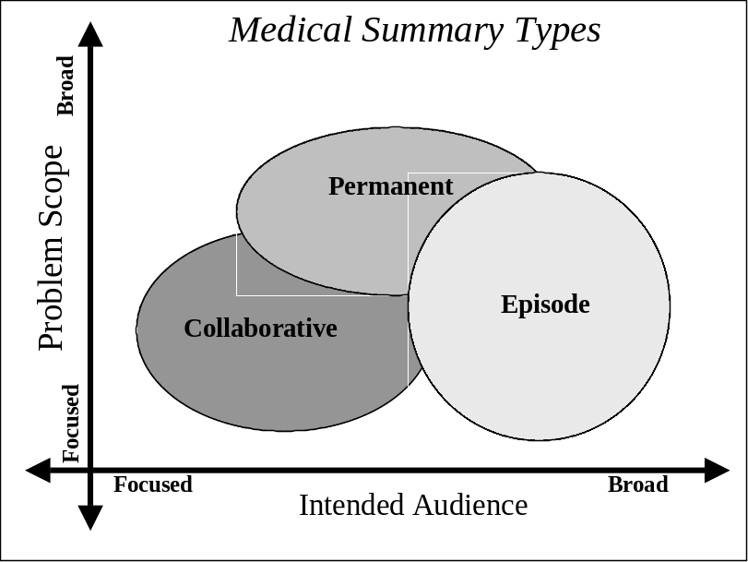Patient transfers, and therefore the summary documents that accompany these transfers can be categorized into 3 primary types: Episodic, Collaborative, or Permanent. These categories are important because they represent a breadth of use case scenarios for Medical Summaries. For example, summaries for collaborative transfers of care such as referral notes have a focused objective for providing the most relevant information about the patient intended for a specific provider. Collaborative summaries have a general audience that generated as an artifact since they also provide the most relevant spot to obtain information about specific classes of patient problems that the patient has.
By contrast, episodic summaries have the primary purpose of highlighting the most relevant details of focused periods of time in a patient history. Examples include discharge summaries or history and physicals. Episodic summaries are written for a broad audience by intent.
Permanent transfers have yet a 3rd purpose of summarizing the entirety of a patient's medical history and therefore covers more broad range of patient problems. The audience may be focused (as in a transfer to a new provider) or general (as in a discharge from the military).
The challenge is then to identify the clinically relevant documents and data elements that belong to typical “transfer of care” scenarios utilized for the continuum of care. The Cross-Enterprise Sharing of Medical Summary (XDS-MS) Integration Profile defines a minimum set of “data elements” that should be forwarded or made available to subsequent care provider(s) during specific transfer of care scenarios. In addition, this integration profile needs to define the utilization requirements/options for the receiving entity in order to ensure that the “care context” of the sending entity is appropriately maintained following the information transfer.

Actors/Transactions
Figure 3.1-1 shows the actors directly involved in the Cross-Enterprise Sharing of Medical Summaries Integration Profile and the relevant transactions between them. Other actors that may be indirectly involved due to their participation in Audit trail and Node Authentication and Consistent Time are not shown.
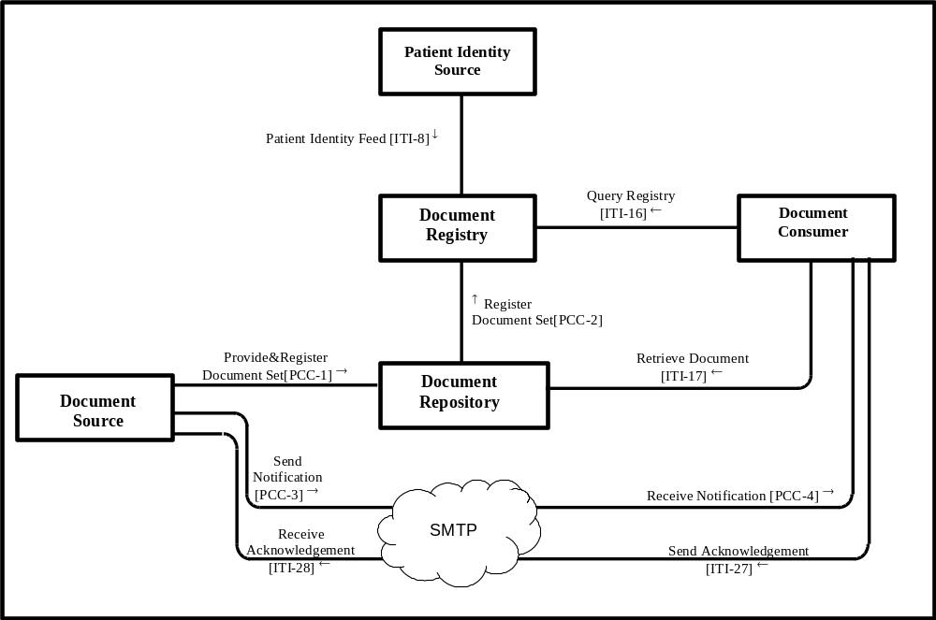
Figure 3.1-1 Cross-Enterprise Sharing of Medical Summaries Diagram

Table 3.1-1 XDS - Actors and Transactions
Actors | Transactions | Optionality | Section in Vol. 2
Document Consumer | Query Registry | R | ITI TF-2:3.16
Document Consumer | Retrieve Document | R | PCC TF-2:4.3
Document Source | Provide and Register Document Set | R (Note 1) | PCC TF-2:4.1
Document Repository | Provide and Register Document Set | R (Note 1) | PCC TF-2:4.1
Document Repository | Register Document Set | R (Note 2) | PCC TF-2:4.2
Document Repository | Retrieve Document | R | PCC TF-2:4.3
Document Registry | Register Document Set | R (Note 2) | PCC TF-2:4.2
Document Registry | Query Registry | R | ITI TF-2:3.16
Document Registry | Patient Identity Feed | R | ITI TF-2:3.8
Patient Identity Source | Patient Identity Feed | R | ITI TF-2:3.8
Note 1: The Provide and Register Document Set is not required in implementations where the Document Source is grouped with the Document Repository Actor.
Note 2: The Register Document Set Transaction is not required in implementations where the Document Registry Actor is grouped with the Document Repository Actor. However, it is strongly recommended that these transactions be supported to allow for future configuration with multiple Repositories.

Actors

Document Source Actor
The Document Source Actor is the producer and publisher of documents. It is responsible for sending documents to a Document Repository Actor. It also supplies metadata to the Document Repository Actor for subsequent registration of the documents with the Document Registry Actor and may notify of document availability.

Document Consumer Actor
The Document Consumer Actor queries a Document Registry Actor for documents meeting certain criteria, and retrieves selected documents from one or more Document Repository actors. It may be notified of document availability.

Document Registry Actor
The Document Registry Actor maintains metadata about each registered document in a document entry. This includes a link to the Document in the Repository where it is stored. The Document Registry responds to queries from Document Consumer actors about documents meeting specific criteria. It also enforces some healthcare specific technical policies at the time of document registration.

Document Repository Actor
The Document Repository is responsible for both the persistent storage of these documents as well as for their registration with the appropriate Document Registry. It assigns a URI to documents for subsequent retrieval by a Document Consumer.

Patient Identity Source Actor
The Patient Identity Source Actor is a provider of unique identifier for each patient and maintains a collection of identity traits. The Patient Identify Source facilitates the validation of patient identifiers by the Registry Actor in its interactions with other actors.

Transactions

Provide and Register Document Set
A Document Source Actor initiates the Provide and Register Document Set Transaction. For each document in the submitted set, the Document Source Actor provides both the documents as an opaque octet stream and the corresponding metadata to the Document Repository. The Document Repository is responsible to persistently store these documents, and to register them in the Document Registry using the Register Documents transaction by forwarding the document metadata received from the Document Source Actor.

Register
A Document Repository Actor initiates the Register Document Set transaction. This transaction allows a Document Repository Actor to register one or more documents with a Document Registry, by supplying metadata about each document to be registered. This document metadata will be used to create an XDS Document Entry in the registry. The Document Registry Actor ensures that document metadata is valid before allowing documents to be registered. If one or more documents fail the metadata validation, the Register Document Set transaction fails as a whole.

Query Registry
The Document Consumer Actor issues the Query Registry transaction to a Document Registry. The Document Registry Actor searches the registry to locate documents that meet the provider’s specified query criteria. It will return a list of document entries that contain metadata found to meet the specified criteria including

Retrieve Document
A Document Consumer Actor initiates the Retrieve Document transaction. The Document Repository will return the document that was specified by the Document Consumer.

Patient Identity Feed
It conveys the patient identifier and corroborating demographic data, captured when a patient’s identity is established, modified or merged or in cases where the key corroborating demographic data has been modified. Its purpose in the XDS Integration Profile is to populate the registry with patient identifiers that have been registered for the affinity domain.

XDS-MS Integration Profile Options
Options that may be selected for this Integration Profile are listed in the table X.2-1 along with the Actors to which they apply. Dependencies between options when applicable are specified in notes.
Table X.4-1 Actors and Options
Actor | Options | Vol & Section
Document Source | Discharge Summary Option(1)  Referral Option (1) | PCC TF-1: 3.4.1  PCC TF-1: 3.4.2
Document Consumer | View Option  Document Import Option  Section Import Option  Discrete Data Import Option | PCC TF-1: 3.4.3  PCC TF-1: 3.4.4  PCC TF-1: 3.4.5  PCC TF-1: 3.4.6
Document Registry | No Options | -
Document Repository | No Options | -
Patient Identity Feed | No Options | -
Note 1 : The Document Source shall support either one or both of these options.

Discharge Summary Option
The Document Source that supports the Discharge Summary Option shall be able to support the Provide and Register Document Set Transaction (PCC TF-2: 3.1) or Register Document Set Transaction PCC-2 in a manner that meets the requirements sets by Medical Summary Content Profile (See PCC TF-3) for discharge Summary content.
Note: All discharge summaries shall be structured and coded as required by the Medical Summary Content Profile. The inclusion of the specific coded attributes explicitly defined as optional, may be supported by specific implementations of Document Sources using an IHE identified coded terminology (See PCC TF-3: Appendix A) of their choice.. The requirements and manner in which implementations support such capabilities is beyond the scope of this Integration Profile.

Referral Option
The Document Source that supports the Referral Option shall be able to support the Provide and Register Document Set Transaction (PCC TF-2: 3.1) or Register Document Set Transaction PCC-2 in a manner that meets the requirements sets by Medical Summary Content Profile (See PCC TF-3) for referral content.
Note: All referral summaries shall be structured and coded as required by the Medical Summary Content Profile. The inclusion of the specific coded attributes explicitly defined as optional, may be supported by specific implementations of Document Sources using an IHE identified coded terminology (See PCC TF-3: Appendix A) of their choice.. The requirements and manner in which implementations support such capabilities is beyond the scope of this Integration Profile.

View Option
The Document Consumer that supports the View Option shall be able to support the Query of Document Metadata necessary by the Document Consumer for its proper Document rendering (Mime type, format code) as well as the Retrieve Document Transaction (PCC TF-2: 3.1) in a manner that supports the rendering of the entire document content, both for discharge summary or referral. This rendering shall meet the requirements defined for CDA Release 2 content presentation semantics (See Section 1.2.4, Human readability and rendering CDA Documents). CDA Header information providing context critical information shall also be rendered in a human readable manner. If a style sheet is attached to the document, it is strongly recommended to offer a means to apply it.
A document after viewing may be discarded by the Document Consumer.
The Document Consumer may allow the provider to print paper copies of any viewable document.
When a viewed Document contains a link to another document, the Document Consumer supporting the View Option shall offer to its users the transparent use of the link information to identify the related document.

Document Import Option
This Option requires that the View Option be supported. In addition, the Document Consumer that supports the Document Import Option shall be able to support the storage of the entire document (integral byte stream as provided by the XDS Repository along with sufficient metadata to ensure its later viewing) both for discharge summary or referral. This Option requires that the user be offered the possibility to consider the document part of the local patient record with the proper tracking of its origin. A Document Consumer, that supports Document Import Option shall offer shall offer a means to view the document without the need to query the Document Registry or retrieve it again from the Document Repository. When viewed after it was imported, a Document Consumer may chose or not to query the Document Registry to be notified if the related Document viewed has been deprecated, replaced or addended.

Section Import Option
This Option does not require that the View Option be supported. The Document Consumer that supports the Section Import Option shall be able to support the storage of one or more sections of the document (along with sufficient metadata to ensure its later viewing) both for discharge summary or referral. This Option requires that the user be offered the possibility to select specific section(s) to import as part of the local patient record with the proper tracking of its origin. A Document Consumer, that supports Section Import Option shall offer shall offer a means to view the imported section(s) without the need to query the Document Registry or retrieve it again from the Document Repository. When viewed after it was imported, a Document Consumer may chose or not to query the Document Registry to notify the user if the Document related to the Section viewed has been deprecated, replaced or addended. This Option does not require the Document Consumer to support the extraction of a subset of a section.

Discrete Data Import Option
This Option does not require that the View, Import Document or Section Import Options be supported. In addition, the Document Consumer that supports the Discrete Data Import Option shall be able to support the storage of one or more sections of the document (along with sufficient metadata to ensure its later viewing). This Option requires that the user be offered the possibility to select specific sections within which an clinically relevant subset (e.g. a problem or an allergy in a list) may be further selected for import as part of the local patient record with the proper tracking of its origin. When discrete data is accessed after it was imported, a Document Consumer may chose or not to query the Document Registry to notified the user if the Document related to the discrete data viewed has been deprecated, replaced or addended.
Note: All medical summaries shall be structured and coded as required by the Medical Summary Content Profile. The import of the specific coded attributes explicitly defined as optional, may be supported by specific implementations of Document Consumers supporting the IHE identified coded terminology (See PCC TF-3: Appendix A) used by the Document Source that created the Medical Summary. The requirements and manner in which implementations support such capabilities is beyond the scope of this Integration Profile.

Grouping with Other Profile Actors

Notification of Document Availability (NAV)
A Document Source shall provide the capability to issue a Send Notification Transaction per the Notification of Document Availability (NAV) Integration Profile in order to notify one or more Document Consumer(s) of the availability of one or more documents for retrieval. One of the Acknowledgement Request options may be used to request from a Document Consumer that an acknowledgement should be returned when it has received and processed the notification.
A Document Consumer shall provide the capability to receive a Receive Notification Transaction per the Notification of Document Availability (NAV) Integration Profile in order to be notified by Document Sources of the availability of one or more documents for retrieval. The Send Acknowledgement option may be used to issue a Send Acknowledgement to a Document Source that the notification was received and processed.

Cross Enterprise User Authentication (XUA)
A Document Consumer Actor of the XDS-MS Integration Profile may provide positive identification of the user on behalf of which it is acting in order to support access control decision making by the XDS Registry and Repositories. To do so, it must be grouped with an X-Service User Actor of the Cross-Enterprise User Authentication Integration Profile.

Document Digital Signature (DSG)
When a Document Source Actor of the XDS-MS Integration Profile needs to digitally sign a medical summary or any other documents in a submission set, it may support the Digital Signature Content Profile as a Document Source. The digital signature(s) documents are registered with the XDS Registry that associates it with the signed document.
When a Document Consumer Actor of the XDS-MS Integration Profile needs to verify a Digital Signature, it may query and retrieve the digital signature document and may perform the verification against the signed document content.

XDS-MS Integration Profile Process Flow
The basic process flow supported by XDS-MS mirrors current manual practices: someone gather the appropriate documents from the patient medical record, copy them, package them up with a cover letter explaining the reason the information is being sent, and then ship the package to the receiving provider. This is often accompanied by a telephone call from the sending provider to the receiving provider that indicates that such information is forthcoming. In cases of unplanned care, it is generally difficult to find out from where to request information about the patient.
It is expected that the transfers of care will occur in an environment where the physician offices and hospitals are coordinated within a regional health information organization that serve the information sharing needs of a community of care settings. A registry/repository-based infrastructure supported by the IHE Cross-Enterprise Document Sharing and other IHE Integration Profiles such as patient identification (PIX & PDQ), security and privacy (CT, ATNA, XUA), and notification of availability of documents (NAV) are used (See IHE IT Infrastructure Technical Framework). Such an infrastructure will be assumed in the following use cases that will focus on the context for defining the specific clinical information content for Medical Summaries.
Because the Collaborative care transfers and Episodic Care transfers differ significantly, two use cases are defined. Implementers of this Integration Profile may implement one or both of these use cases.

Use Case 1: Ambulatory Specialist Referral
This use case involves a “collaborative” transfer of care for the referral of a patient from a primary care provider (PCP) to a specialist. This use case is a central component of an “e-referral” process, which typically requires an appropriate level of agreement/collaboration between the two parties prior to the actual transfer of clinical information being initiated.
The preconditions assume a PCP seeing a patient in his office. The PCP has talked to the patient and performed an examination, and has decided to refer the patient to a specialist. An assumption is made that the PCP has an EMR system with capability to write notes and manage data elements. The specific data elements managed by the PCP’s EMR are expected to be the source for the information used in creating the medical summary document related to this transfer of care. A variety of EMR implementations and usage by clinicians may result in some variability in the content of the medical summary.
The detailed content of the medical summary to support this use case will be detailed as part of the document content profile specification (See Volume 3, Section 1 for the Medical Summary Content Profile – US Realm).
Steps to identify the specialist, and obtain insurance preauthorization have been placed out of scope for this Integration Profile.
Post conditions included the specialist physician receiving the notification of referral, locating the documents (via the Document Registry), retrieving the Documents and viewing them and optionally importing data. Import assumes the specialist with an EMR system with the capability for managing those discrete data elements.
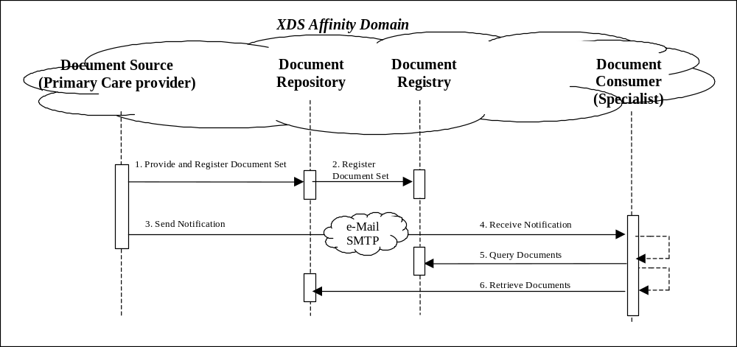
Figure 3.7-1 Use Case 1: Ambulatory Specialist Referral
These steps are:
- Package a collection of records into an XDS Submission Set. This submission contains a Medical Summary, and may contain a number of other related clinical documents. The medical summary is a clinical document (already known in the paper world), which serves the dual purpose of documenting an encounter, and providing the rationale for sending the information to another provider. This step utilizes the transactions provided by the ITI XDS profile to place the records in an XDS Repository (local or shared).
- The Repository en sure that the documents of the submission set are registered with the XDS Registry of the Affinity Domain (set of cooperating care delivery institutions).
- The next step is to notify the other provider that documents are now available for review. This step utilizes the transactions provided by the ITI NAV profile to perform the e-mail notification.
- The e-mail notification contains no patient identified information is received by the specialist EMR system.
- The receiving provider can then utilize existing query transactions from the XDS profile to find the URL of the Documents.
- Finally, the receiving provider may choose to import relevant information from these records into their own EMR system.

Use Case 2: Acute Care Discharge to Ambulatory Care Environment
This use case involves an episodic transfer of care in the form of a patient discharge from a hospital to home. The attending physician in the hospital generates a discharge summary document that is used by the hospital record keeping and billing abstraction. The attending physician in the hospital may or may not also be serving as the patients ambulatory PCP. If not, a copy of this record is sent to the PCP as well as other specialist providers that will have ambulatory follow-up care.
The preconditions of this use case involve a specialist surgeon seeing a patient in the hospital after an operation. The surgeon is ready to discharge the patient, who will be following up in the surgeon's office as well as with his ambulatory PCP. It is assumed the surgeon has been using the hospitals EMR which has capability for a physician documentation function to construct the Discharge Summary. It is further assumed that this documentation component may call other relevant data elements (for example the list of current medications) needed in the construction of the document. It is noted that variability in EMR implementations and usage may result in considerable variability in the content of the medical summary.
The events of the use case involve creation of the discharge summary and sending it to the PCP’s office and the surgeon’s office.
The post conditions include the receipt and viewing of the discharge summary with optional import into the ambulatory EMR system.
The detailed content of the medical summary to support this use case will be detailed as part of the document content profile specification (See Volume III, Section 1 for the Medical Summary Content Profile – US Realm).
This use case uses the same set of transactions and differ only by the content of the Medical Summary.
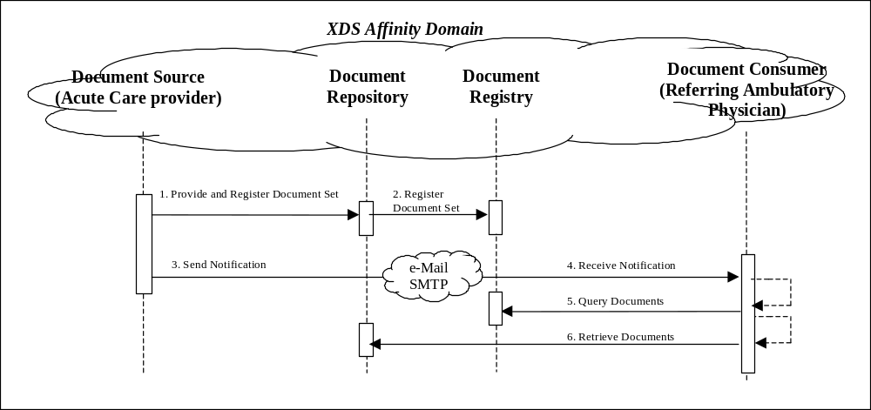
Figure 3.7-2 Use Case 2: Acute Care Discharge to Ambulatory Care Environment

National extensions of Medical Summaries: regional content specialization use case
This Cross-Enterprise Sharing of Medical Summaries Integration Profile is specialized in term of detailed content of sections and information elements by a set of Document Content Profiles specific to each regions or countries. Additional Content profiles may be expected to be included in the future to support other countries.

Use Case for Interoperability Levels
This Cross-Enterprise Sharing of Medical Summaries Integration Profile requires the source of medical summaries as well as the consumer of medical summaries to interoperate by exchanging a fully structured context for the medical summary document (patient demographics, authors, encounter) and a structured human-readable content of the document content so that the document creator and any display consumer would share a generally consistent presentation of the information. The human readable content is structured with coded sections to ensure that sections be easily extracted by the computer processing.

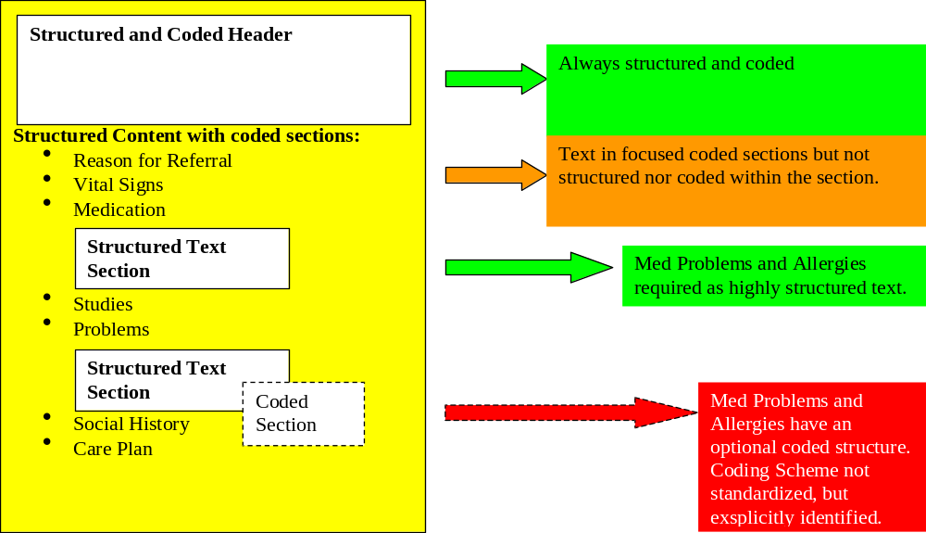
Figure 3.7-3 The three level of interoperability supported – Flexibility and efficiency

In addition to this basic required level that ensures human-to-human communication, selected sections of the document (e.g. problems, medications and allergies in the USA Content Profile) shall support structured textual representation. This structured textual representation allows discrete textual strings to be easily imported.
Note: When a section with a Structured Text definition is used (e.g. medication), each discrete textual strings has a specific meaning (e.g. the dose for a medication), which is computer processable due to the structured information. These discrete textual strings are not duplicate but simply extracts from the human readable text content, reducing the risk for inconsistencies.
This set of selected sections with structured textual representations may be further extended by coded structures that provide a means to encode discrete elements of information through data structures that are computer processable. If any coded terminology is used it is uniquely identified.

Use Case for unplanned access to past Medical Summaries
This use case involves a precondition where a patient has received care from several providers that have created and share a number of Medical Summaries in the past. In case of an emergency, any provider may need to assess the patient care history. Reviewing one or more Medical Summaries, as well as other documents such as laboratory and radiology reports is a critical means for emergency physicians and nurses to provide the best care to patient in these acute conditions.
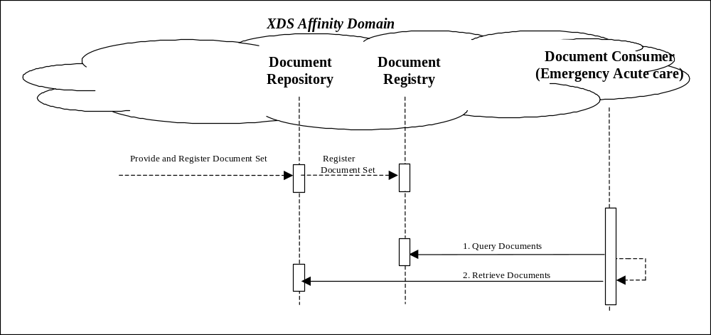
Figure 3.7-3 Unplanned Use Case: Acute Care Emergency

Use Case Conclusion
The process flow of this profile exhibits a great deal more power and flexibility than the existing manual process. The physician workflow is improved by reusing an existing work product in the very first step (the summary report) to accomplish two purposes: recording care that has been provided, and communicating with another provider.
Secondly, each step utilizes the power of inter-connected EMR systems to make the entire process faster, easier, and less reliant on human labor to accomplish the same feats. This results in reduced time to transfer records between providers, safer transport of the information, and more reliable receipt.
Lastly, the process facilitates the import of relevant data from one set of patient records to the receiving physicians EHR system, resulting in more reliable transfer of information, reduced labor costs transferring information from one provider to another and less time required by the patient to provide information that is already in the physician's possession.

Security Considerations
The XDS-MS Integration Profile assumes that a minimum security and privacy environment has been established across all participants. There must exist security policies regarding the use of training, agreements, risk management, business continuity and network security that need to be already in place prior to the implementation of XDS-MS.
The IHE ITI ATNA Integration Profile is required of the actors involved in the XDS transactions specified in this profile to protect node to node communication and to produce an audit trail of the PHI related actions when they exchange messages.
In addition, IHE ITI XUA and DGS Integration Profiles can be applied to the actors involved in the transactions specified in this profile to securely identify individuals involved in transactions (XUA) and verify document integrity and authorizations (DGS).
Interested parties should also read the detailed Security Considerations sections provided for each of the aforementioned profiles in the IHE ITI Technical Framework and its supplements.
The XDS-MS profile does have a few security considerations of its own.
EHR systems should be thoughtfully designed so that providers are able to review and verify information before it is imported into their EHR system, and that positive acknowledgements are made before import, and audit trails are recorded when imports occur.
Imported information should be traceable both to the source [the sharing EHR], and the receiver that accepted it into the EHR system. XDS Affinity domain policies should support policies and procedures for tracing information flows between EHR systems.
Because the information being transferred is in XML, it will be common that different EHR systems utilize different transformations to render the contents into human readable form. A Document Source must make available the transforms used by the sending provider to review the documents, and a Document Consumer must support rendering the information as seen by the sending provider, allowing both providers to see what was sent in its original rendered form.
- Actor Descriptions
Actors are information systems or components of information systems that produce, manage, or act on information associated with operational activities in the enterprise. The following are definitions of actors used in the IHE Patient Care Coordination Integration Profiles:

Document Source - The Document Source Actor is the producer and publisher of documents. It is responsible for sending documents to a Document Repository Actor. It also supplies metadata to the Document Repository Actor for subsequent registration of the documents with the Document Registry Actor.
Document Consumer - The Document Consumer Actor queries a Document Registry Actor for documents meeting certain criteria, and retrieves selected documents from one or more Document Repository actors.
Document Registry - The Document Registry Actor maintains metadata about each registered document in a document entry. This includes a link to the Document in the Repository where it is stored. The Document Registry responds to queries from Document Consumer actors about documents meeting specific criteria. It also enforces some healthcare specific technical policies at the time of document registration.
Document Repository - The Document Repository is responsible for both the persistent storage of these documents as well as for their registration with the appropriate Document Registry. It assigns a URI to documents for subsequent retrieval by a Document Consumer.
Patient Identity Source - The Patient Identity Source Actor is a provider of unique identifier for each patient and maintains a collection of identity traits. The Patient Identify Source facilitates the validation of patient identifiers by the Registry Actor in its interactions with other actors.
Time Client – Establishes time synchronization with one or more Time Servers using the NTP protocol and either the NTP or SNTP algorithms. Maintains the local computer system clock synchronization with UTC based on synchronization with the Time Servers.
- Transaction Descriptions
Transactions are interactions between actors that transfer the required information through standards-based messages. The following are brief descriptions of the transactions defined by IHE.
Provide and Register Document Set - A Document Source Actor initiates the Provide and Register Document Set Transaction. For each document in the submitted set, the Document Source Actor provides both the documents as an opaque octet stream and the corresponding metadata to the Document Repository. The Document Repository is responsible to persistently store these documents, and to register them in the Document Registry using the Register Documents transaction by forwarding the document metadata received from the Document Source Actor.
Register Document Set - A Document Repository Actor initiates the Register Document Set transaction. This transaction allows a Document Repository Actor to register one or more documents with a Document Registry, by supplying metadata about each document to be registered. This document metadata will be used to create an XDS Document Entry in the registry. The Document Registry Actor ensures that document metadata is valid before allowing documents to be registered. If one or more documents fail the metadata validation, the Register Document Set transaction fails as a whole.
Query Registry - The Document Consumer Actor issues the Query Registry transaction to a Document Registry. The Document Registry Actor searches the registry to locate documents that meet the provider’s specified query criteria. It will return a list of document entries that contain metadata found to meet the specified criteria including the locations and identifier of each corresponding document in one or more Document Repositories.
Retrieve Document - A Document Consumer Actor initiates the Retrieve Document transaction. The Document Repository will return the document that was specified by the Document Consumer.
Patient Identity Feed - It conveys the patient identifier and corroborating demographic data, captured when a patient’s identity is established, modified or merged or in cases where the key corroborating demographic data has been modified. Its purpose in the XDS Integration Profile is to populate the registry with patient identifiers that have been registered for the affinity domain.
- IHE Integration Statements
IHE Integration Statements are documents prepared and published by vendors to describe the conformance of their products with the IHE Technical Framework. They identify the specific IHE capabilities a given product supports in terms of IHE actors and integration profiles (described in ITI TF-1: 2).
Users familiar with these concepts can use Integration Statements to determine what level of integration a vendor asserts a product supports with complementary systems and what clinical and operational benefits such integration might provide. Integration Statements are intended to be used in conjunction with statements of conformance to specific standards (e.g. HL7, IETF, DICOM, W3C, etc.).
IHE provides a process for vendors to test their implementations of IHE actors and integration profiles. The IHE testing process, culminating in a multi-party interactive testing event called the Connect-a-thon, provides vendors with valuable feedback and provides a baseline indication of the conformance of their implementations. The process is not intended to independently evaluate, or ensure, product compliance. In publishing the results of the Connect-a-thon and facilitating access to vendors’ IHE Integration Statements, IHE and its sponsoring organizations are in no way attesting to the accuracy or validity of any vendor’s IHE Integration Statements or any other claims by vendors regarding their products.
IMPORTANT -- PLEASE NOTE: Vendors have sole responsibility for the accuracy and validity of their IHE Integration Statements. Vendors’ Integration Statements are made available through IHE simply for consideration by parties seeking information about the integration capabilities of particular products. IHE and its sponsoring organizations have not evaluated or approved any IHE Integration Statement or any related product, and IHE and its sponsoring organizations shall have no liability or responsibility to any party for any claims or damages, whether direct, indirect, incidental or consequential, including but not limited to business interruption and loss of revenue, arising from any use of, or reliance upon, any IHE Integration Statement.
  - Structure and Content of an IHE Integration Statement
An IHE Integration Statement for a product shall include:
- The Vendor Name
- The Product Name (as used in the commercial context) to which the IHE Integration Statement applies.
- The Product Version to which the IHE Integration Statement applies.
- A publication date and optionally a revision designation for the IHE Integration Statement.
- The following statement: “This product implements all transactions required in the IHE Technical Framework to support the IHE Integration Profiles, Actors and Options listed below:”
- A list of IHE Integration Profiles supported by the product and, for each Integration Profile, a list of IHE Actors supported. For each integration profile/actor combination, one or more of the options defined in the IHE Technical Framework may also be stated. Profiles, Actors and Options shall use the names defined by the IHE Technical Framework Volume I. (Note: The vendor may also elect to indicate the version number of the Technical Framework referenced for each Integration Profile.)
Note that implementation of the integration profile implies implementation of all required transactions for an actor as well as selected options.
The statement shall also include references and/or internet links to the following information:
- Specific internet address (or universal resource locator [URL]) where the vendor’s Integration Statements are posted
- URL where the vendor’s standards conformance statements (e.g., HL7, DICOM, etc.) relevant to the IHE transactions implemented by the product are posted.
- URL of the IHE Initiative’s web page for general IHE information www.himss.org/ihe.
An IHE Integration Statement is not intended to promote or advertise aspects of a product not directly related to its implementation of IHE capabilities.
  - Format of an IHE Integration Statement
Each Integration Statement shall follow the format shown below. Vendors may add a cover page and any necessary additional information in accordance with their product documentation policies.

IHE Integration Statement |  |  |  |  |  | Date |  | 12 Oct 2005
Vendor |  | Product Name |  |  |  | Version
Any Medical Systems Co. |  | IntegrateRecord |  |  |  | V2.3
This product implements all transactions required in the IHE Technical Framework to support the IHE Integration Profiles, Actors and Options listed below:
Integration Profiles Implemented |  |  |  | Actors Implemented |  |  | Options Implemented
Retrieve Information for Display |  |  |  | Information Source |  |  | none
Enterprise User Authentication |  |  |  | Kerberized Server |  |  | none
Patient Identity Cross-referencing |  |  |  | Patient Identifier Cross-reference Consumer |  |  | PIX Update Notification
Internet address for vendor’s IHE information: www.anymedicalsystemsco.com/ihe
Links to Standards Conformance Statements for the Implementation
HL7 | www.anymedicalsystemsco.com/hl7
Links to general information on IHE
In North America: www.ihe.het |  |  | In Europe: www.ihe-europe.org |  | In Japan: www.jira-net.or.jp/ihe-j

GLOSSARY

Actor: An entity within a use case diagram that can perform an action within a use case diagram. Possible actions are creation or consumption of a message
ADT: Admit, Discharge & Transfer.
Care Context: The participations surrounding the care provision act, and the attributes of that act. Everything in the document header. Data history, links to clinical reasoning.
CDA: Clinical Document Architecture (specified by HL7).
CT: Consistent Time Integration Profile.
eMPI: Enterprise Master Patient Index.
EMR: Electronic Medical Record, an Electronic Health Record system used within an enterprise to deliver care (also called EHR-CR by IHE-XDS).
EUA: Enterprise User Authentication Integration Profile.
Expected Actions: Actions which should occur as the result of a trigger event.
HIMSS: Healthcare Information and Management Systems Society.
HIS: Hospital Information System.
IHE: Integrating the Healthcare Enterprise.
Interaction Diagram: A diagram that depicts data flow and sequencing of events.
IT: Information Technology.
MPI: Master Patient Index.
MRN: Medicare Record Number.
OID: Object Identifier. (See also 'Globally Unique Identifier’).
Patient Identifier Cross-reference Domain: Consists of a set of Patient Identifier Domains known and managed by a Patient Identifier Cross-reference Manager Actor. The Patient Identifier Cross-reference Manager Actor is responsible for providing lists of “alias” identifiers from different Patient Identifier Domains.
Patient Identifier Domain: A single system or a set of interconnected systems that all share a common identification scheme for patients. Such a scheme includes: (1) a single identifier-issuing authority, (2) an assignment process of an identifier to a patient, (3) a permanent record of issued patient identifiers with associated traits, and (4) a maintenance process over time. The goal of Patient Identification is to reduce errors.
PDF: Portable Document Format.
Process Flow Diagram: A graphical illustration of the flow of processes and interactions among the actors involved in a particular example.
Role: The actions of an actor in a use case.
RSNA: Radiological Society of North America.
sig.: A Latin abbreviation for signetur used to represent the instruction following the medication name.
Scope: A brief description of the transaction.
Trigger Event: An event such as the reception of a message or completion of a process, which causes another action to occur.
UID: Unique Identifier (See also Globally Unique Identifier).
Universal ID: Unique identifier over time within the UID type. Each UID must belong to one of specifically enumerated species. Universal ID must follow syntactic rules of its scheme.
Use Case: A graphical depiction of the actors and operation of a system.
ACC, HIMSS and RSNA
Integrating the Healthcare Enterprise

IHE Patient Care Coordination
Technical Framework
Volume 2 - Transactions

2005-2006

Public Comment Draft July 22, 2005

Comments due August 22, 2005

Introduction
Integrating the Healthcare Enterprise (IHE) is an initiative designed to stimulate the integration of the information systems that support modern healthcare institutions. Its fundamental objective is to ensure that in the care of patients all required information for medical decisions is both correct and available to healthcare professionals. The American College of cardiology (ACC), the Healthcare Information and Management Systems Society (HIMSS), the Radiological Society of North America (RSNA) are the current sponsors of this initiative. Other organizations representing healthcare professionals are invited to join with them.
The IHE initiative is both a process and a forum for encouraging integration efforts. It defines a technical framework for the implementation of established information exchange standards to achieve specific clinical goals. It includes a rigorous testing process for the implementation of this framework. And it organizes educational sessions and exhibits at major meetings of medical professionals to demonstrate the benefits of this framework and encourage its adoption by industry and users.
The approach employed in the IHE initiative is not to define new integration standards, but rather to support the use of existing standards⎯initially DICOM and HL7, but potentially others, as appropriate in their respective domains⎯in an integrated manner, defining configuration choices when necessary. When clarifications or extensions to existing standards are necessary, IHE refers recommendations to the relevant standards bodies.

Overview of Technical Framework
This document, the IHE Technical Framework, defines specific implementations of established standards to achieve integration goals that promote appropriate sharing of medical information to support optimal patient care. It is expanded annually, after a period of public review, and maintained regularly through the identification and correction of errata. The latest version of the document is always available via the Internet at www.ihe.net.
The IHE Technical Framework defines a subset of the functional components of the healthcare enterprise, called IHE Actors, and specifies their interactions in terms of a set of coordinated, standards-based transactions. It defines this body of transactions in progressively greater depth. Volume I provides a high-level view of IHE functionality, showing the transactions organized into functional units called Integration Profiles that highlight their capacity to address specific clinical needs.

Overview of Volume II
Section 2 presents the conventions used in this volume to define the transactions implemented under IHE.
Section 3 provides an overview of the concepts of IHE actors and transactions used in IHE to define the functional components of a distributed healthcare environment.
Section 4 defines transactions in detail, specifying the roles for each actor, the standards employed, the information exchanged, and in some cases, implementation options for the transaction.
The appendices following the main body of this volume provide clarification of technical details of the IHE data model and transactions. The final section of the volume is a glossary of terms and acronyms used in the IHE Technical Framework, including those from relevant standards.

Audience
The intended audience of this document is:
- Technical staff of vendors planning to participate in the IHE initiative
- IT departments of healthcare institutions
- Experts involved in standards development
- Anyone interested in the technical aspects of integrating healthcare information systems

Relationship to Standards
The IHE Technical Framework identifies functional components of a distributed healthcare environment solely from the point of view of their interactions in the healthcare enterprise. At its current level of development, it defines a coordinated set of transactions based on an expanding number of standards.
In some cases, IHE recommends selection of specific options supported by these standards; however, IHE does not introduce technical choices that contradict conformance to these standards. If errors in or extensions to existing standards are identified, IHE’s policy is to submit those to the appropriate standards bodies for resolution within their conformance and standards evolution strategy. IHE is therefore an implementation framework, not a standard. Referencing IHE as a standard and claiming conformance to IHE are both inappropriate. Conformance claims must be made in direct reference to specific standards. Conformance statements may, however, state that the products they describe are “implemented in accordance with the IHE Technical Framework”. See Volume I, Appendix C for the suggested form of such statements.
IHE encourages implementers to ensure that products implemented in accordance with the IHE Technical Framework also meet the full requirements of the standards underlying IHE, allowing the products to interact, although possibly at a lower level of integration, with products that have been implemented in compliance with the standards but that may not meet the IHE requirements.

Relationship to Real-world Architectures
The actors and transactions described in the IHE Technical Framework are abstractions of the real-world healthcare information system environment. While some of the transactions are traditionally performed by specific product categories (EMR, Clinical Systems, etc.), the IHE Technical Framework intentionally avoids associating functions or actors with such product categories. For each actor, the IHE Technical Framework defines only those functions associated with integrating information systems. The IHE definition of an actor should therefore not be taken as the complete definition of any product that might implement it, nor should the framework itself be taken as the complete definition of a healthcare information system architecture.
The reason for defining actors and transactions is to provide a basis for defining the interactions among functional components of the healthcare information system environment. In situations where a single physical product implements multiple functions, only the interfaces between the product and external functions in the environment are considered to be significant by the IHE initiative. Therefore, the IHE initiative takes no position on the relative merits of an integrated environment based on a single, all-encompassing information system versus one based on multiple systems that together achieve the same end.

Comments
HIMSS and RSNA welcome comments on this document and the IHE initiative. They should be directed to the discussion server at http://ihe.rsna.org/ihetf/ or to:
Joyce Sensmeier
Director of Professional Services
230 East Ohio St., Suite 500
Chicago, IL 60611
Email: ihe@himss.org

Copyright Permission
Health Level Seven, Inc., has granted permission to the IHE to reproduce tables from the HL7 standard. The HL7 tables in this document are copyrighted by Health Level Seven, Inc. All rights reserved.
Material drawn from these documents is credited where used.

Conventions
This document has adopted the following conventions for representing the framework concepts and specifying how the standards upon which the IHE Technical Framework is based should be applied.

The Generic IHE Transaction Model
Transaction descriptions are provided in section 4. In each transaction description, the actors, the roles they play, and the transactions between them are presented as use cases.
The generic IHE transaction description includes the following components:
- Scope: a brief description of the transaction.
- Use case roles: textual definitions of the actors and their roles, with a simple diagram relating them, e.g.:
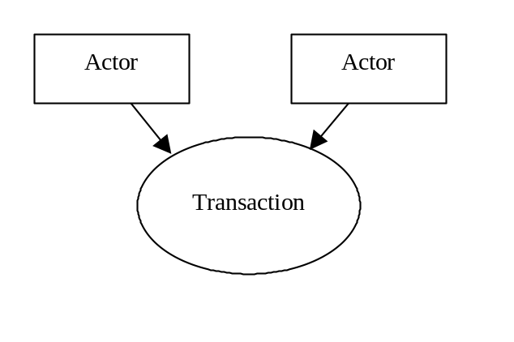
- Referenced Standards: the standards (stating the specific parts, chapters or sections thereof) to be used for the transaction.
- Interaction Diagram: a graphical depiction of the actors and transactions, with related processing within an actor shown as a rectangle and time progressing downward, similar to:
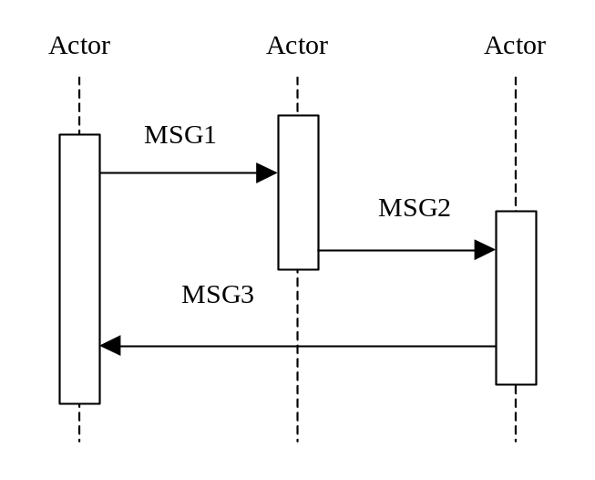
The interaction diagrams used in the IHE Technical Framework are modeled after those described in Grady Booch, James Rumbaugh, and Ivar Jacobson, The Unified Modeling Language User Guide, ISBN 0-201-57168-4. Simple acknowledgment messages are omitted from the diagrams for brevity.
- Message definitions: descriptions of each message involved in the transaction, the events that trigger the message, its semantics, and the actions that the message triggers in the receiver.

Framework Overview
The IHE Technical Framework is based on actors that interact through transactions.
Actors are information systems or components of information systems that produce, manage, or act on information associated with operational activities in the enterprise.
Transactions are interactions between actors that transfer the required information through standards-based messages.
The implementation of the transaction described in this Volume 2 support the specification of Integration Profiles (see PCC TF-1).

IHE Transactions
This section defines each IHE transaction in detail, specifying the standards used, and the information transferred.

Provide and Register Document Set
This section corresponds to Transaction PCC-1 of the IHE Technical Framework.

Scope
This Transaction is used to send a submission set containing a Medical Summary and related documents from one provider's EHR system to a Document Repository of an XDS Affinity Domain.

Use Case Roles
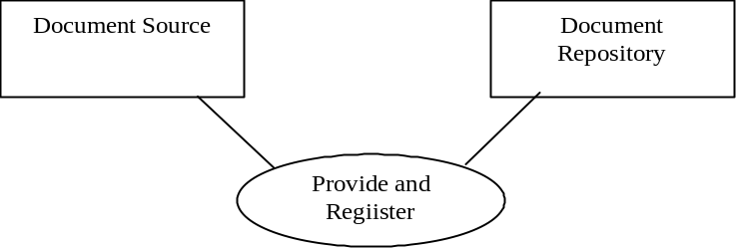
Actor: Document Source
Role: A system that submits documents and associated metadata to a Document Repository.
Actor: Document Repository
Role: A document storage system that receives documents and associated metadata and:
- Stores the documents
- Enhances submitted metadata with repository information to enable later retrieval of documents
Forwards the enhanced metadata to the Document Registry.

Referenced Standards
This transaction builds upon transactions from the IHE ITI Cross Enterprise Document Sharing (XDS), IHE ITI Notification of Document Availability (NAV), and the Medical Summaries Content Profile in Volume 3 of the PCC Technical Framework.

Interaction Diagram

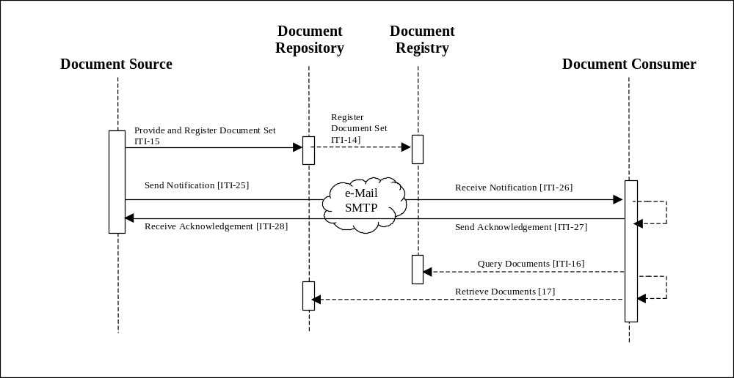

Provide and Register Transaction

Trigger Events
Upon completion of a discharge or transfer summary for an inpatient stay.
Upon completion of a summary of episode with the intention of referral to another provider.

Message Semantics
The Document Source will prepare an XDS Submission Set containing a Medical Summary document as defined by the Medical Summary Content Profile found in Volume 3 of the PCC Technical Framework, and submit that to a repository using Transaction ITI-15 Provide and Register Document Set.
The Document Source should include within this submission set a copy of any document referenced by the Medical Summary so contained, and may include additional documents.
The Document Source shall support the preparation and sending of an ITI XDS-25 Notification of Document Availability message to the Document Source, once the registration has been successful. The mechanism by which the Document Source is identified is left unspecified, but should support provider interaction to select the appropriate destination(s) for the notification(s).
The Document Source may request for an acknowledgement, and if so requested may wait for an Acknowledgement.

Expected Actions
The Document Source will ensure that all documents form the Submission Set are registered, or report an error [to the user or system administrator] if registration cannot be completed.
The Document Source will send a Notification of Document Availability Message to the Document Consumer(s).
The Document Source may wait for an Acknowledgement from the Document Consumer(s), and take appropriate actions if one is not received in an application configurable period of time. Such actions may include resending the Notification Message, reporting the lack of acknowledgement to the originating provider, logging the failure, etc.

Register Document Set
This section corresponds to Transaction PCC-2 of the IHE Technical Framework.

Scope
This Transaction is used to register metadata about a submission set containing a Medical Summary and related documents from one provider's EHR system to a Document Registry of an XDS Affinity Domain.

Use Case Roles
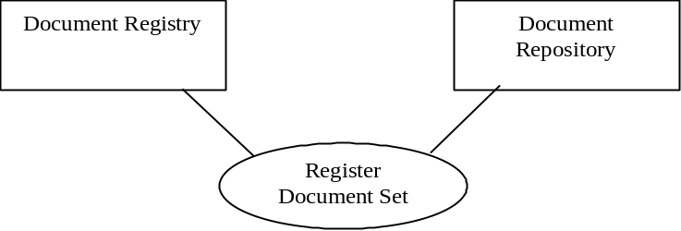
Actor: Document Repository
Role: A document storage system that submits document metadata to a Document Registry.
Actor: Document Registry
Role: A document indexing system that receives and stores document metadata.

Referenced Standards
This transaction builds upon transactions from the IHE ITI Cross Enterprise Document Sharing (XDS), IHE ITI Notification of Document Availability (NAV), and the Medical Summaries Content Profile in Volume 3 of the PCC Technical Framework.

Interaction Diagram

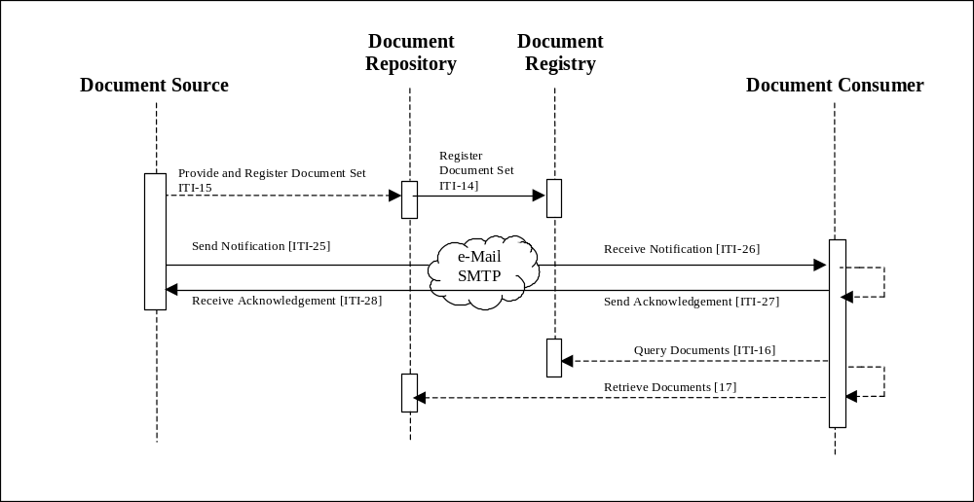

Register Transaction

Trigger Events
Upon receipt of a Provide and Register Transaction.
When a repository is grouped with a Document Source, upon completion of a discharge or transfer summary for an inpatient stay.
When a repository is grouped with a Document Source, upon completion of a summary of episode with the intention of referral to another provider.

Message Semantics
When the Document Source is not grouped with a Document Repository this transaction is identical to ITI-14.
When the Document Source is grouped with a Document repository:
- they shall prepare an XDS Submission Set containing a Medical Summary document as defined by the Medical Summary Content Profile found in Volume 3 of the PCC Technical Framework, and register it to a registry using Transaction ITI-14 Register Document Set.
- The Document Source/Repository should include within this submission set a copy of any document referenced by the Medical Summary so contained, and may include additional documents.
- The Document Source/Repository shall support the preparation and sending of an ITI XDS-25 Notification of Document Availability transaction to the Document Source, once the registration has been successful. The mechanism by which the Document Source is identified is left unspecified, but should support provider interaction to select the appropriate destination(s) for the notification(s).
- The Document Source/Repository may request for an acknowledgement, and if so requested may wait for an Acknowledgement.

Expected Actions
The Document Repository will ensure that all documents form the Submission Set are registered, or report an error [to the user or system administrator] if registration cannot be completed.
The Document Source will send a Notification of Document Availability Message to the Document Consumer(s).
The Document Repository may wait for an Acknowledgement from the Document Consumer(s), and take appropriate actions if one is not received in an application configurable period of time. Such actions may include resending the Notification Message, reporting the lack of acknowledgement to the originating provider, logging the failure, etc.

Retrieve Document
This section corresponds to Transaction PCC-3 of the IHE Technical Framework.

Scope
This Transaction is used by a Document Consumer upon a local user decision to browse the Document registry or when alerted to retrieve and process a Submission Set incluing a Medical Summary.

Use Case Roles
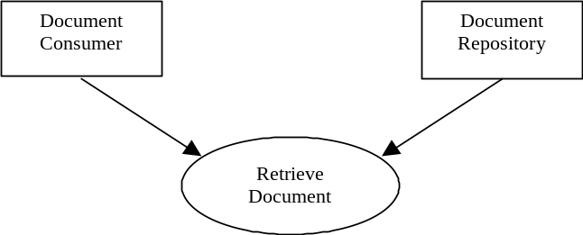
Actor: Document Consumer
Role: Obtains document.
Actor: Document Repository
Role: Provides documents.

Referenced Standards
See IHE ITI Cross Enterprise Document Sharing (XDS), IHE ITI Notification of Document Availability (NAV), and the Medical Summaries Content Profile in Volume III of the PCC Technical Framework.

Interaction Diagram
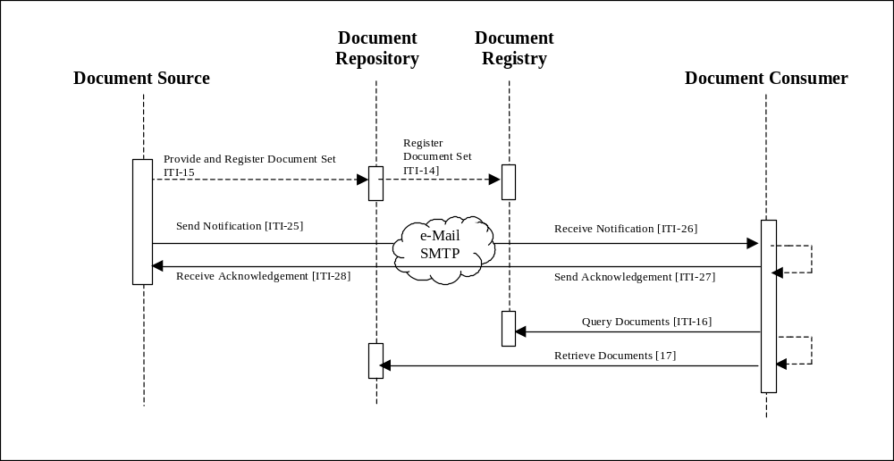

Retrieve Document

Trigger Events
Upon receipt of a notification of document availability message that references a Medical Summary Document.

Message Semantics
If an acknowledgment is requested, the Document Consumer shall initiate an ITI-27 Send Acknowledgment transaction. The Document Consumer shall notify the provider designated in the Notification message of the received package.
The Document Consumer shall query the repository for appropriate metadata using the ITI-16 Query Documents transaction. More than one Medical Summary document may be present in the Submission Set. However, the nature of the Provide and register and Register transactions are such that the most recently created Medical Summary is "the" Medical Summary that drove the creation of the Submission Set. Other Medical Summaries are prior medical Summaries that may not have been published. In general prior Medical Summaries with be submitted by reference.
The Document Consumer shall request the content of the Medical Summary document using the IHE ITI-17 Retrieve Document transaction.
The Document Consumer may request the content of other related documents using IHE ITI-17 Retrieve Document transaction, and may initiate further queries using the IHE ITI-16 transaction.

View Option
When this option is implemented, the requirements defined in PCC TF-1 :3.5.3 shall be met.

Import Document Option
When this option is implemented, the requirements defined in PCC TF-1 :3.5.4 shall be met.

Import Sections Option
When this option is implemented, the requirements defined in PCC TF-1 :3.5.5 shall be met.

Import Discrete Data
When this option is implemented, the requirements defined in PCC TF-1 :3.5.6 shall be met.

NAV should supply the event code of the submission set, so that receivers can initiate different processing activities based on this code. XDS-MS will define an event code for the Submission Set that indicates that the set is part of the PCC-1 or PCC-2 transaction.

